Properties and Characteristics of Raster Data

In raster datasets, each cell (which is also known as a pixel) has a value. The cell values represent the phenomenon portrayed by the raster dataset such as a category, magnitude, height, or spectral value. The category could be a land-use class such as grassland, forest, or road. A magnitude might represent gravity, noise pollution, or percent rainfall. Height (distance) could represent surface elevation above mean sea level, which can be used to derive slope, aspect, and watershed properties. Spectral values are used in satellite imagery and aerial photography to represent light reflectance and color.
Cell value
Cell values can be either positive or negative, integer, or floating point. Integer values are best used to represent categorical (discrete) data, and floating-point values to represent continuous surfaces.
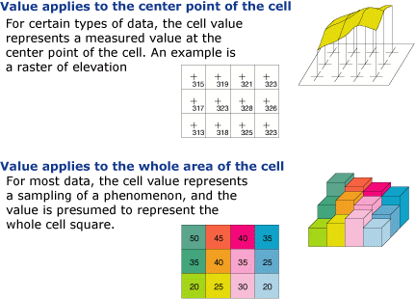
Each cell value in a raster dataset has a value, representing the characteristic of a spatial phenomenon at the location denoted by its row and column. The value may be a category, height, spectral value, or magnitude. The category may be a land use class such as forest, grassland, lake, or residential region. The height may be a surface elevation above mean sea level and can be used to derive slope, aspect, and watershed properties. The spectral value in satellite imagery or aerial photography could represent the light reflectance and color. The magnitude could represent pollutant concentration, rainfall or snowfall. A cell value can be either positive or negative, integer, or floating point. Integer cell values are mostly used to represent discrete data while floating point values are best used to represent continuous data. Cells without data have a NoData value.

No Data
Each cell in a raster dataset has a value assigned to it, representing the characteristic of a spatial phenomenon at the cell location. If no valid information or insufficient information about the particular characteristics of the cell location is available, the cell is assigned the No Data value.
Displaying raster data
Raster data can be displayed on the computer as a binary image, grayscale image or colormap image, depending on the number of bits used to display each cell. If each cell is displayed using 1 bit, each cell has a value of 0 or 1 and displayed using black and white. If n bits are used to display raster data in a grayscale image, each cell has a value from 0 to 2^n-1, corresponding to different grays. If n bits are used to display raster data in a colormap image and the RGB color model is used, then the cells could be displayed in up to 2^3n different colors.
Rows and Columns
A raster model consists of rows, columns, and cells. The origin of rows and columns is at the upper left corner of the grid. Rows function as y-coordinates and columns as x-coordinates in a two dimensional coordinate system. A cell is defined by its location in terms of row and column.
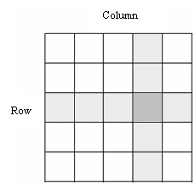

Cell size(Resolution)
When working with imaged raster data, you may concern with different types of resolution, e.g. spatial resolution, spectral resolution, temporal resolution, and radiometric resolution. In a GIS, you are most often concerned with the spatial resolution of a raster dataset, which is determined by the cell size. A cell size of 30 meters means that each cell measures 900 square meters on the ground.
The higher the resolution of a raster, the smaller the cell size. So a raster image of high resolution for a ground area has more cells than a raster image of low resolution for the same area. A higher resolution means greater detail, but also increases the data volume and the data processing time.

Spatial extent
In a GIS, a raster dataset represents features in a space of specific extent. The extent can be defined by planar x, y coordinates or by latitudes and longitudes. In most cases, you only need to know x, y coordinates, or atitude and longitude, of the upper left corner (usually the origin of rows and columns). The extent of the dataset can be computed by the number of rows, columns, and the cell size.

Properties and Characteristics of Vector Data
Vector is a data structure, used to store spatial data. Vector data is comprised of lines or arcs, defined by beginning and end points, which meet at nodes. The locations of these nodes and the topological structure are usually stored explicitly. Features are defined by their boundaries only and curved lines are represented as a series of connecting arcs
Vector representation of data
In the vector based model (figure 4), geospatial data is represented in the form of co-ordinates. In vector data, the basic units of spatial information are points, lines (arcs) and polygons. Each of these units is composed simply as a series of one or more co-ordinate points, for example, a line is a collection of related points, and a polygon is a collection of related lines.
co-ordinate
Pairs of numbers expressing horizontal distances along orthogonal axes, or triplets of numbers measuring horizontal and vertical distances, or n-numbers along n-axes expressing a precise location in n-dimensional space. Co-ordinates generally represent locations on the earth's surface relative to other locations.
point
A zero-dimensional abstraction of an object represented by a single X,Y co-ordinate. A point normally represents a geographic feature too small to be displayed as a line or area; for example, the location of a building location on a small-scale map, or the location of a service cover on a medium scale map.
line
A set of ordered co-ordinates that represent the shape of geographic features too narrow to be displayed as an area at the given scale (contours, street centrelines, or streams), or linear features with no area (county boundary lines). A lines is synonymous with an arc.
arc
An ARC/INFO term that is used synonymously with line.
polygon
A feature used to represent areas. A polygon is defined by the lines that make up its boundary and a point inside its boundary for identification. Polygons have attributes that describe the geographic feature they represent.

Advantages/disadvantages of raster and vector data models
 | raster | vector
precision in graphics
traditional cartography
data volume
topology
computation
update
continuous space
integration
discontinuous

